Name: ___________________________________________________________________

Agency: _________________________________________________________________

Address: _________________________________________________________________

City: ________________________________________ Zip:_________________________

Email: _______________________________________Phone: ______________________
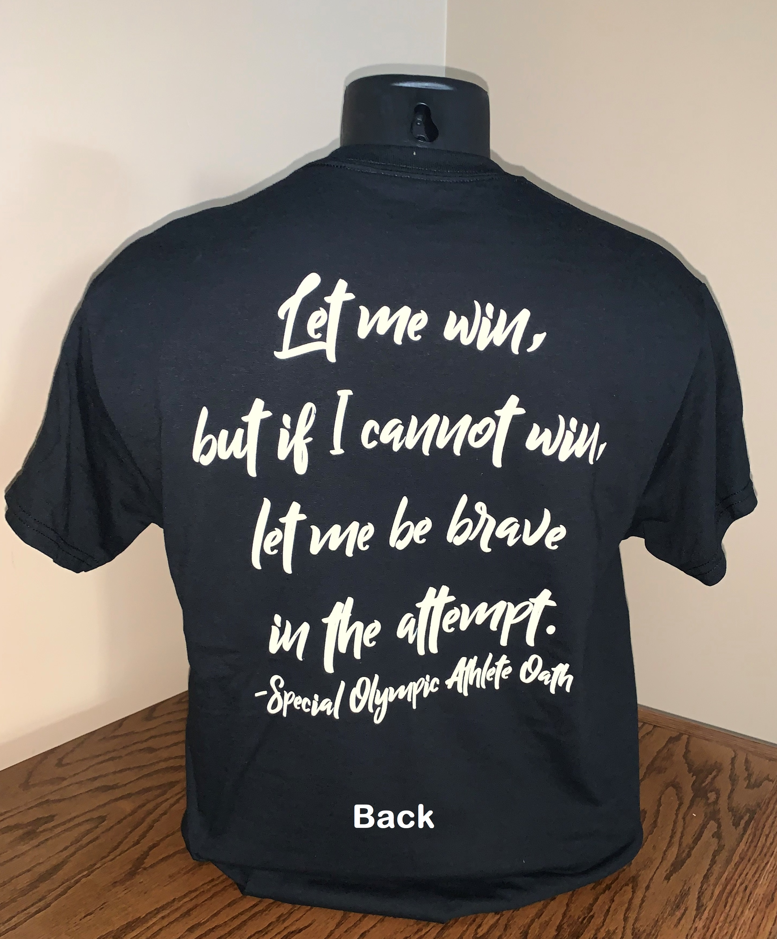
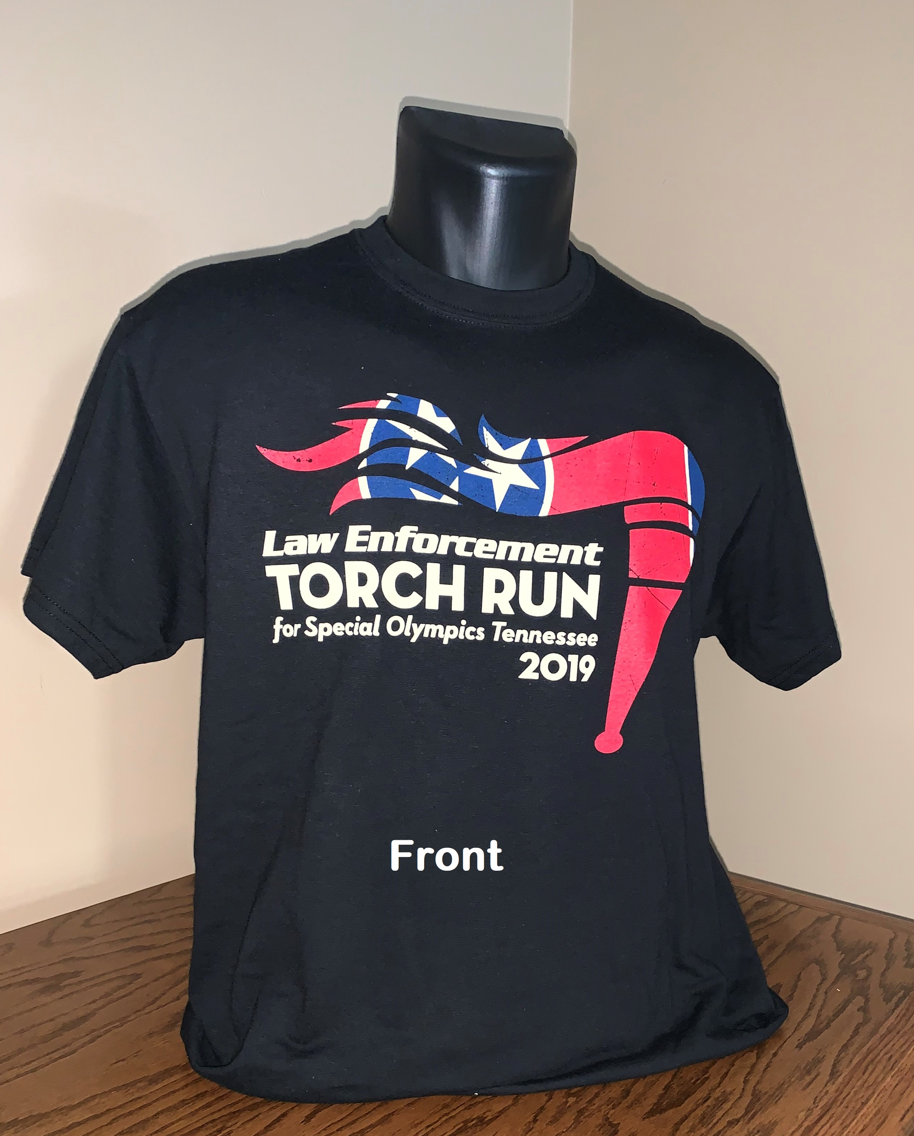

LETR Cotton T-Shirt ($20.00) Quantity requested
Small ______________
Medium ______________
Large ______________
XL ______________
XXL ______________
XXXL ______________

Form can be forwarded to Amy Parker at aparker@specialolympicstn.org or faxed to 615-327-1465.

Sales Agreement
By signing this agreement form I agree to sell all items I requested by May 17, 2019. If all items are not sold at that time, I agree to return them to the Special Olympics Tennessee office by May 19, 2019.

______________________________________ __________________
Signature of Seller Date

