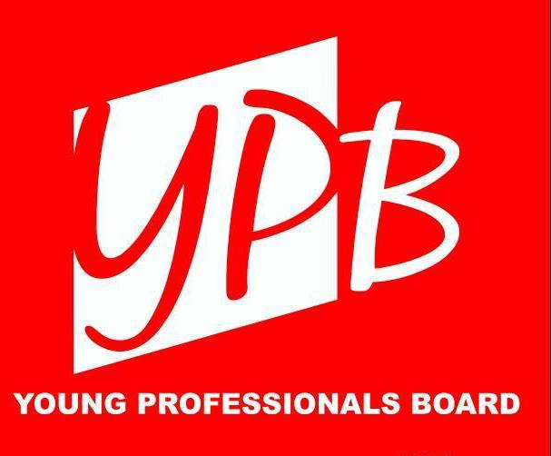

The YPB engages the community to allow all athletes to pursue their dreams by volunteering, fundraising, and increasing awareness of Special Olympics.

New Board Member Application
Special Olympics Tennessee Young Professional Board

Special Olympics Tennessee's Young Professionals Board (YPB) is a group of young professionals under 40 who are dedicated to increasing community awareness and raising funds for Special Olympics while supporting the organization's mission. The YPB is part of the Special Olympics Tennessee family and is tasked with helping direct the future endeavors of the organization. Board member expectations include:

- Attend 60% of monthly meetings; estimated ten (10) meetings per year
- Volunteer for at least three (3) major Special Olympics events
- Actively participate in the planning of the Mini Masters , a YPB Signature Event
- Maintain communication with co-chairs and assigned committees
  - RSVP “No” to meetings that cannot be attended
  - Participate in group surveys and requests for feedback
- Promote the YPB and the Special Olympics of Tennessee

As part of the application process, we like to talk with each applicant either in person or on the phone. We will try to reach out at a convenient time for you to discuss the application process in depth. The application timeline is as follows:
- From November 15 – April 14, New Applicants must attend three events (one volunteering event, one networking event, and one board meeting as a guest) before being invited to serve on the board in that calendar year.
- From April 15 to November 14, New Applicants must attend three events (one volunteering event, one networking event, and one board meeting as a guest) before being invited to serve on the board in the following calendar year. During the balance of the current calendar year, applicants are invited to serve with the YP Ambassadors.
New Board Member Application
Special Olympics Tennessee Young Professional Board

First Name: _______________________________________________________________________

Last Name: _______________________________________________________________________

Address: _______________________________________________________________________

_______________________________________________________________________

City: _______________________________________________________________________

State: _________________ Zip: ________________________

Email: _______________________________________________________________________

Preferred Phone Number: _______________________________________________________

Current Employer: _______________________________________________________________________

Job Title: _______________________________________________________________________

Email Address: _______________________________________________________________________

Phone Number: _______________________________________________________________________

Please list your strengths:

Please describe how your strengths will benefit the YPB.

Do you have any previous experience with SOTN? If yes, please describe.

Why did you decide to apply to the Young Professionals Board?

What unique attributes will you bring to the YPB?

What is the best time of day/week for one of the chairs to reach out to you to speak about your application?

Please send your application to Ryan Stahr at ryan.j.stahr@gmail.com.

After your application is received and reviewed, our Membership Chair, Ryan Stahr, will contact you. Thank you for your interest in joining Special Olympics Tennessee’s Young Professional Board!

